Mettler-Toledo TGA/DSC 3+ GmbH, Analytical, Germany

TGA/DSC measures the mass of the sample and energy absorbed as it is heated or cooled. The instrument offers the automatic adjustment of mass, temperature and the inert atmosphere. The system is installed with Star e software programmed with ASTM E698 useful is studying the thermodynamic and kinetic parameters.
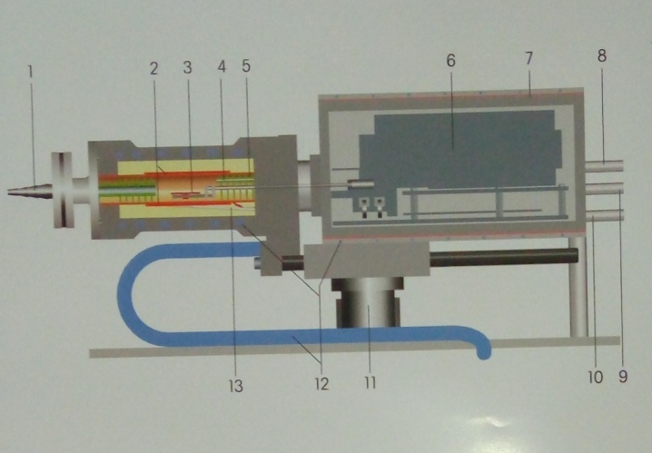
A section through a TGA ultra microscope balance:
1. Gas outlet
2. Furnace Heater
3. Temperature sensor (SOTA, OTA)
4. Reactive gas capillary
5. Baffles
6. Parallel guided ultra microbalance
7. Thermo stated balance chamber
8. Protected gas inlet
9. Reactive gas inlet
10. Purge gas inlet
11. Motor for opening sample chamber
12. Cooling circuit
13. Furnace temperature sensor
- Features and benefits of the TGA/DSC
- Unparelled performance-ultra micro performance over the entire weighing range.
- Very low minimum weight of 5gms on balances-measure samples accurately and precisely.
- Wide temperature range-analyze samples from ambient to 1600ºC
- DSC heat flow measurement-for simultaneous detection of thermal effects.
- Automated TGA-FTIR, TGA-MS, TGA-GCMS systems-perform accurate evolved gas analysis.
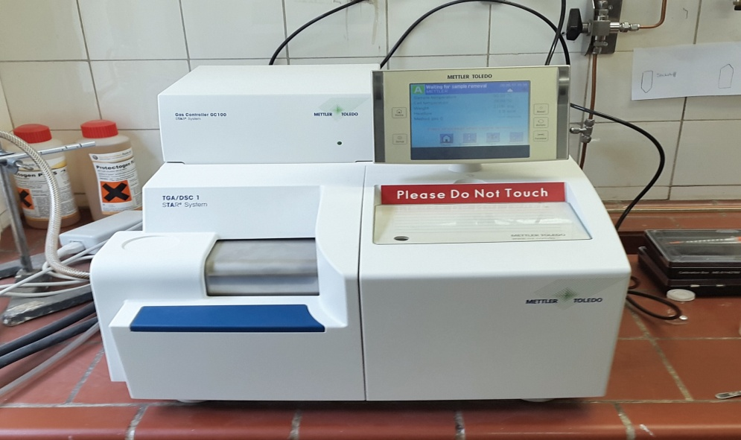

Teacher Incharge:
Dr. Kowsar Majid
Associate Professor
Room No. 229
Department of Chemistry
NIT Srinagar

TGA/DSC

